

**Lab 4: 8-bit DAC**

**CECS 347**

**Kenny Khut, Kuldeep Gohil**

**November 18, 2019**

**Lab Description:**

The purpose of this lab is to create a function generator using the MCP4801 DAC. The lab will generate one of four signals, sawtooth wave, triangle wave, square wave, or sinusoid. Each signal will be generated within a specific frequency. The signal and frequency generated are controlled through UART with the LCD displaying the type of signal generated, the frequency of the signal, and 2 time periods of the waveform on the LCD in the plot area. The signal is sent through the MCP4801 DAC and into an oscilloscope which will display the wave signal that is being generated based on the UART.

**Schematic:**

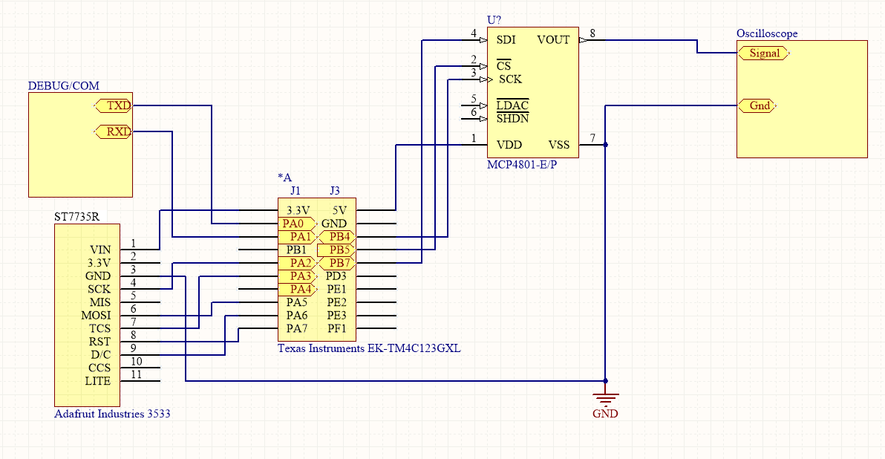

**C source code:**

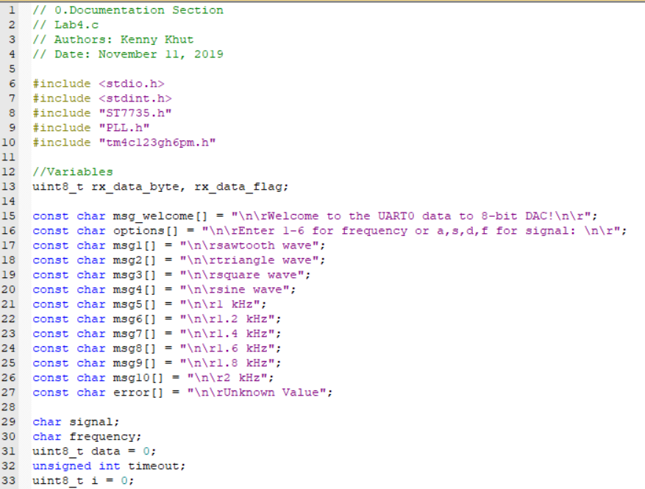

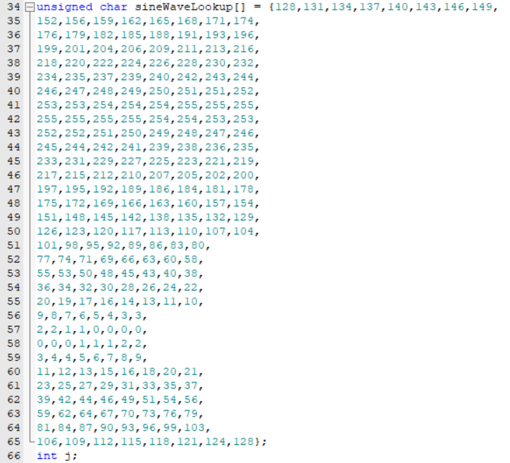

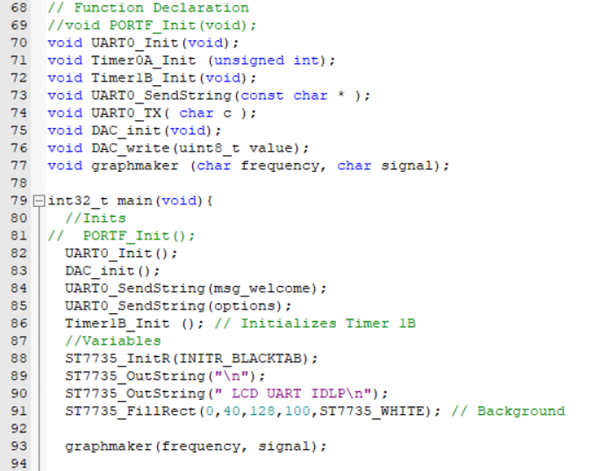

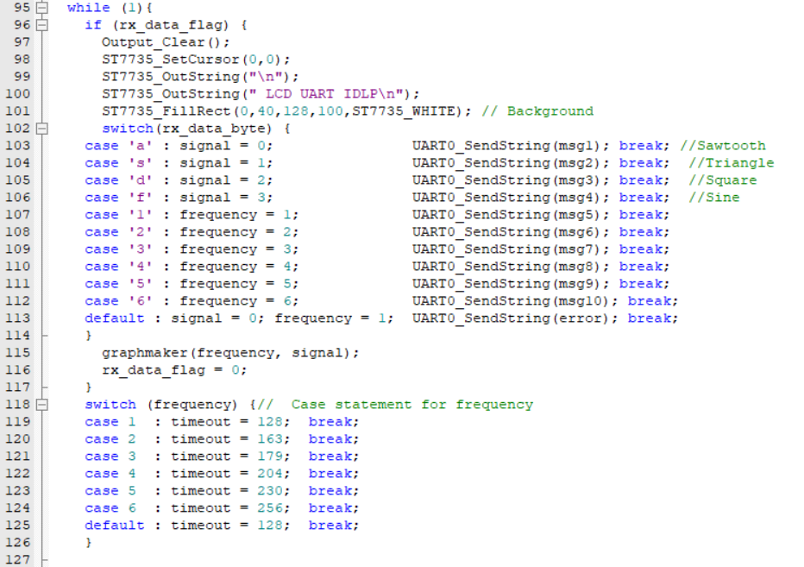

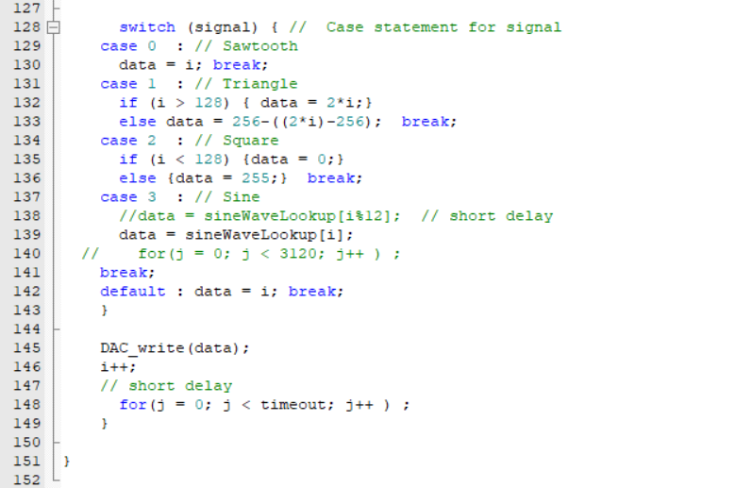

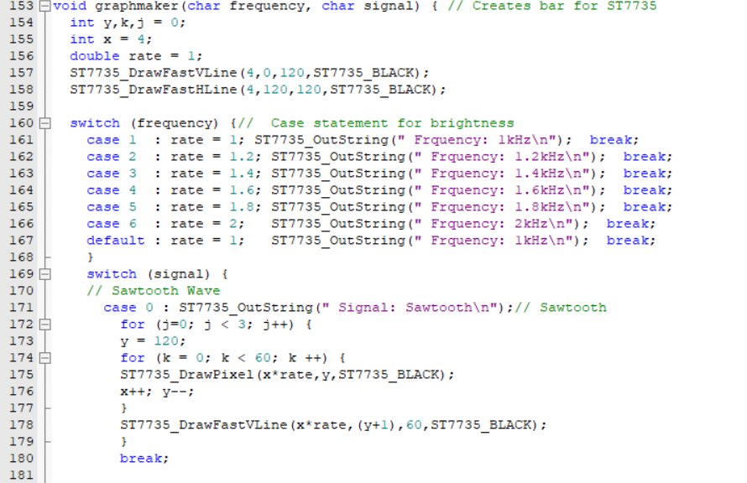

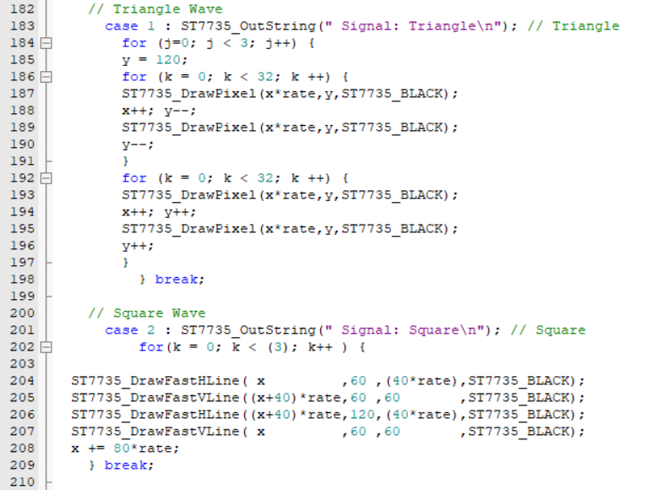

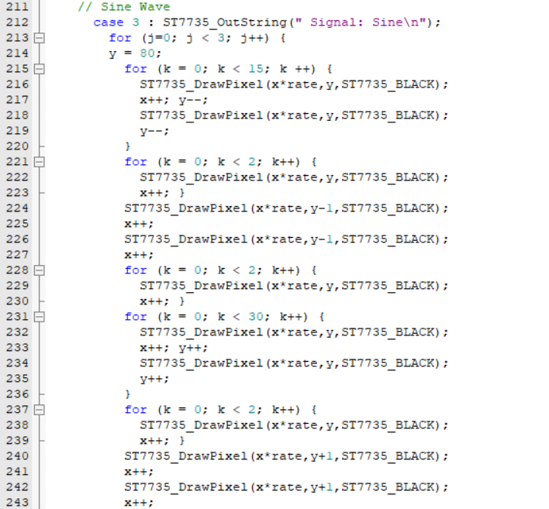

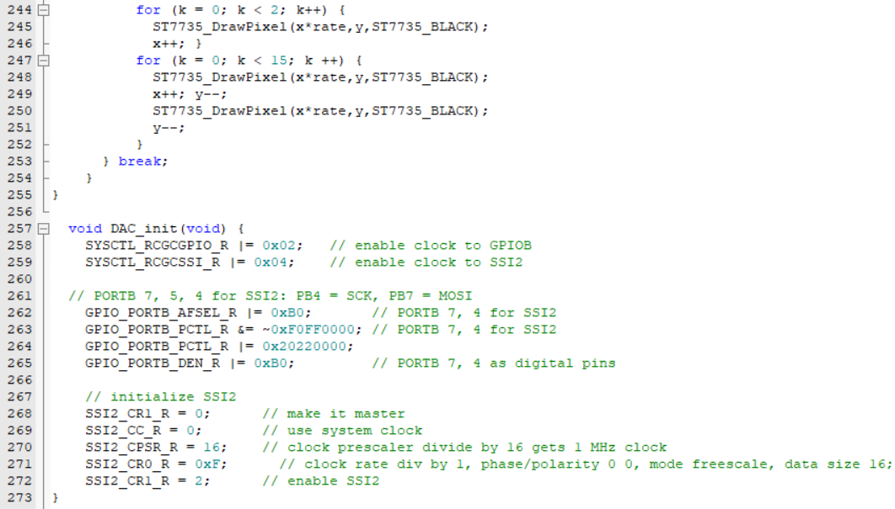

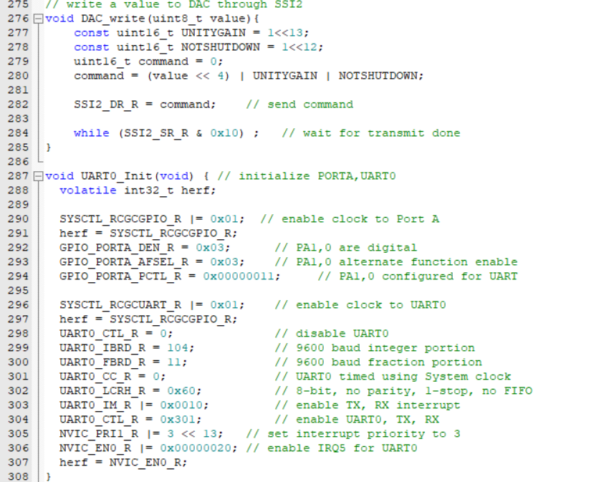

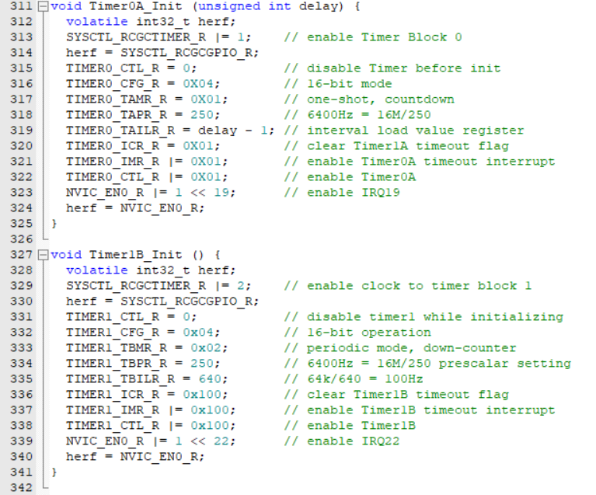

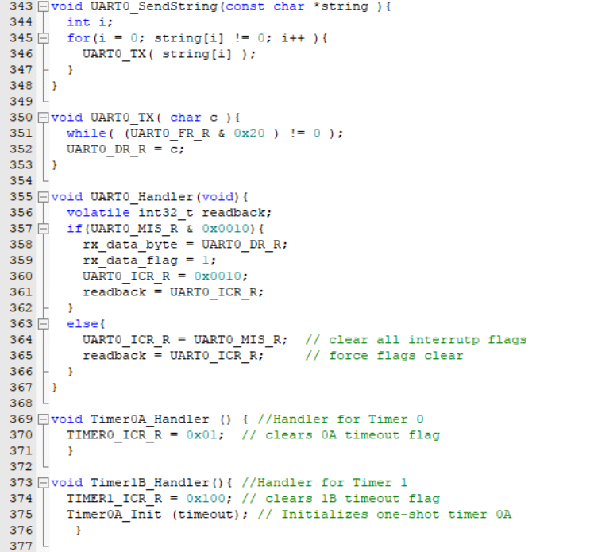

**Conclusion:**

In conclusion, this lab allowed us to understand how to create a function generator using the MCP4801 DAC with four signals. These signals included sawtooth wave, triangle wave, square wave, and sinusoid. Each signal was generated based on the range of frequency specified in the command set. The LCD displayed the type of signal which was being generated and the frequency of the signal itself. Through this lab we were better able to understand how to use an oscilloscope and an LCD synchronously as outputs for the TM4C123GXL Launchpad board.